DATA ANALYSIS
Univariate and Bivariate
Dataset:Placement
1.2)Replace the nan values with correct value.And justify why
you have chosen the same
Ans:
In the Placement dataset salary column has some nan values. So we can replace the nan with “zero”.Because the salary column is depends on status column. Status column has 2 values. one is “placed “another one is “not placed”.If status column fill with “placed” then salary column contain some values otherwise salary column has nan values.
Why I choosed “Zero”? if the person had placed then we will give salary otherwise not.so I will put “zero”instead of nan values.

1.3)How many of them are Not Placed from the dataset?
Ans:
67 persons are Not Placed.

1.4)Find the reason for non placement from the dataset?
Ans:
Failing to prepare for interviews.

1.5)What kind of relation between salary and mba_p?
Ans:
Correlation between salary and mba_p is: 0.139823
This is positive correlation that means independent variable is directly proportional to dependent variable.
If the person pass in mba_p then salary will increase only 13 percentage.

1.6)Which specialization is getting minimum salary?
Ans:
Minimum salary is=200000
mkt & hr, mkt & fin specialization is getting minimum salary.

1.7)How many of getting above 500000 salary?
Ans:
Three Employees are getting above 500000 salary
1.8)Test the Analysis of Variance between etest_p and mba_p
at signifance level 5%.(Make decision using Hypothesis
Testing)
Ans:
Using one way classification the answer is
F_onewayResult(statistic=98.64487057324706, pvalue=4.672547689133573e-21)
p-value <0.05 reject null hypothesis.In this case accept alternative hypothesis.There is significance difference between e-test and mba_p.
1.9)Test the similarity between the degree_t(Sci&Tech) and
specialisation Mkt&HR) with respect to salary at
significance level of 5%.(Make decision using Hypothesis
Testing)
Ans:
Using T-test(Unpaired Test-Different Group but Same Condition) the output is
TtestResult(statistic=2.692041243555374, pvalue=0.007897969943471179, df=152.0)
Pvalue is less than 0.05. So we reject null hypothesis. There is no significant difference respect to salary.

1.10) Convert the normal distribution to standard normal
distribution for salary column
Ans:
Using Z-score we can convert the normal distribution to standard normal distribution
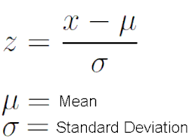

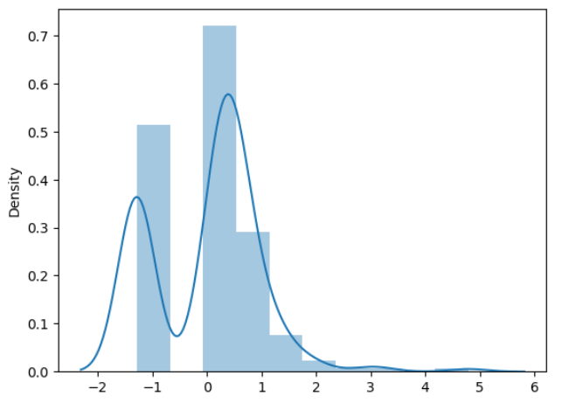.
1.11)What is the probability Density Function of the salary
range from 700000 to 900000?
Ans:
The area between range(700000,900000):0.0005973310593974901
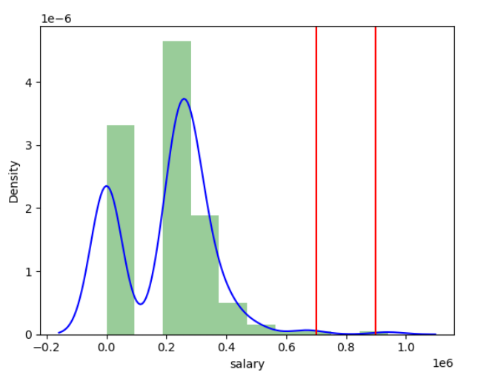
70 to 90 percentage of probability to increased the salary from 700000 to 900000.

1.12)Test the similarity between the degree_t(Sci&Tech)with
respect to etest_p and mba_p at significance level of 5%
(Make decision using Hypothesis Testing)

Ans:
Using T-test(Paired Test-Same Group but Different Condition) the output is
TtestResult(statistic=5.0049844583693615, pvalue=5.517920600505392e-06, df=58)

Pvalue is greater than 0.05. So we accept alternative hypothesis. There is significant difference respect to to etest_p and mba_p.

1.13)Which parameter is highly correlated with salary?
Ans:
Using variance_inflation_factor we can find answer.
VIFvalue comes between 1 and 5.So ssc_p, hsc_p,degree_petest_p and mba_p are Moderately Correlated.

1.14) plot any useful graph and explain it.
Ans:
Seaborn's pairplot function is a powerful tool for visualizing pair wise relationships in a dataset. Using pairplot we can find multicolinearity between the columns. Multicolinearity means any Linear Relationship between columns.

